Grade 11: PROMPT: Write an Essay on Obsession. This is a Synthesis Essay, which means you incorporate elements from more than one source to support your Thesis Statement. In this case you are using three Sources: A, B, and C. Source A is your primary source so must be your focus. A definition of obsession should be in your Introduction; best if the definition is tweaked to suit your understanding, not simply copied from a dictionary.

Chapters 1-10 of The Picture of Dorian Gray by Oscar Wilde is Source A

Printed here below, Song and Summary of the play Faust by Wolfgang Von Goethe, - published 1808 is Source B

Gretchen am Spinnrade – Goethe Gretchen at the spinning-wheel
English Translation © Richard Stokes

My peace is gone
My heart is heavy;
I shall never
Ever find peace again.
When he’s not with me,
Life’s like the grave;
The whole world
Is turned to gall.
My poor head
Is crazed,
My poor mind
Shattered.
My peace is gone
My heart is heavy;
I shall never
Ever find peace again.
It’s only for him
I gaze from the window,
It’s only for him
I leave the house.
His proud bearing
His noble form,
The smile on his lips,
The power of his eyes,
And the magic flow
Of his words,
The touch of his hand,
And ah, his kiss!
My peace is gone
My heart is heavy;
I shall never
Ever find peace again.
My bosom
Yearns for him.
Ah! if I could clasp
And hold him,
And kiss him
To my heart’s content,
And in his kisses
Perish!

Goethe's Faust: A Summary as it applies to Gretchen
The narrative of Faust begins in Heaven. While angels worship The Lord for his creation, Mephistopheles, the Devil, complains about the state of affairs in the world. Mankind is corrupt, he claims, and he revels in the evil and disaster that he is able to cause. Mephistopheles makes a bet with The Lord that he will be able to turn one of his servants, Dr. Faust, over to sin and evil. The Lord agrees, claiming that Faust will remain loyal, his good side will predominate.

The play introduces Faust while he sits in his study in despair over his life. He has been a scholar and an alchemist, and he feels as though he has come to the end of all knowledge, that he will never have a moment of great insight…To show Faust a taste of his power, Mephistopheles summons a group of spirits that take Faust on a hallucinatory journey while Faust falls asleep.

When Faust awakens, Mephistopheles returns, this time with a wager. The Devil promises to serve Faust for 24 years and to give Faust a moment of transcendence. If Mephistopheles succeeds, Faust must then be his servant for the rest of eternity in hell. Faust, being both moral and immoral, takes the wager, believing that the Devil can never give him such a moment. Mephistopheles tells Faust to prepare for their journey…

Mephistopheles takes Faust first to Auerbach's Cellar, a tavern. He tries to convince Faust that the men there have found their true pleasure; they are men who enjoy their lives in the tavern. Faust is unconvinced, however, by their crude cares and simple lives.
Faust and the Devil travel to a witch's cave. Mephistopheles makes the witch give a small bit of her potion to Faust, who drinks it. Outside on a street, Faust meets a young girl with whom he immediately falls in love. Gretchen avoids his advances but cannot help but think about the older, noble stranger she met on the road that day.

Faust and Mephistopheles sneak into Gretchen’s room. In her room, Faust realizes that the feelings he has for the girl are complex, and he longs to be near her. When Gretchen returns, they exit, but Mephistopheles leaves behind a box of jewels. When Gretchen finds the jewels, she cannot believe that they are for her, yet she also cannot help but put them on and admire them. Faust orders Mephistopheles to have the two of them meet.
Gretchen visits her neighbor, Martha, to fret over her mother's actions. Her mother, upon seeing Gretchen’s jewels, promptly took them to a priest, who could tell that they were from an evil source. Later, Gretchen finds another box of jewels, and Martha encourages her not to tell her mother this time. They answer a knock at the door and discover Mephistopheles disguised as a traveler. He weaves a story for Martha, telling her that her husband has died on his long travels (a lie). (During this encounter, Mephistopheles puts a spell on Gretchen to fall in love with Faust.) Martha is both heartbroken and angry at the stories of her husband's licentious life. To put the matter to rest, Martha asks Mephistopheles and another witness to come and legally attest to her husband’s death. The Devil agrees to bring someone, as long as Gretchen will also be present.

That evening in Martha's garden, Gretchen and Faust meet formally for the first time. Faust charms her and courts her. She tells him of her hard life and of how she nursed her sick infant sister until her sister died. Gretchen has no other family except her brother, who is away at war, and her mother. When Faust professes his love for Gretchen, she plays a game of “He loves me/He loves me not” with a flower. She lands on “he loves me” and runs to her room. Faust follows her to a summer cabin, where they say goodbye.
Faust, fearing that he will corrupt the girl with his feelings, runs away to the forest, where he lives for a time in a cave. He thanks the Spirit of Nature for giving him such feelings, for now he has a moment and an understanding of life that he does not want to lose. Mephistopheles finds Faust and derides his foolish behavior, hiding from the woman that he loves. He tells Faust that Faust must find this girl, for she pines away for him day and night. Faust, his passion overtaking him, agrees that he must go.
Source C - “The Kiss” by Gustav Klimt…1862-1918…Periods: Vienna Secession · Art Nouveau · Symbolism · Modern art

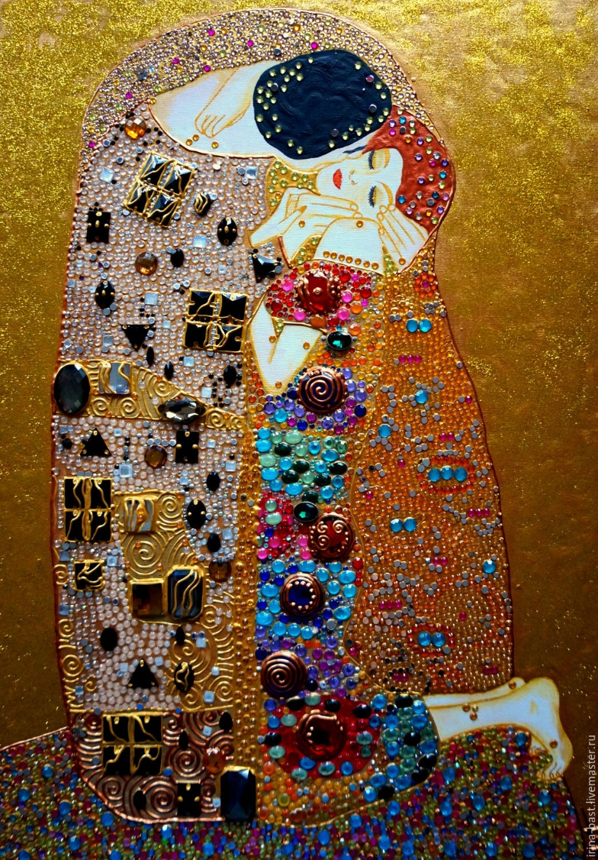

This is a formal essay, so do not use first-person pronouns except in the Conclusion.
Your Introduction needs a Clear Thesis Statement; this is Critical. Your Conclusion must end with an Impact Statement – an aphorism of your own, based on your analyses, would be particularly relevant/appropriate/Impacting.
Citations from the novel are necessary. MLA and Works Cited Page are required
Begin with a Heading, followed by a Title which MUST NOT be the title of the novel.
Length: 2000 words is reasonable. Font: Arial, size 12 or 13 Due: Monday, October 5 OR 12.

