Student Demographics

Student Count
In 2011, Five Stars Academy began with 5 students. We continued to sporadically net increase the number of students each year with the following chart depicting student count from 2017. This is the first year (2020-2021) that we have seen a net decrease. This appears to be linked specifically to the current situation of 2020. It’s also important to note the difficulty in predicting year to year what the budget will be.

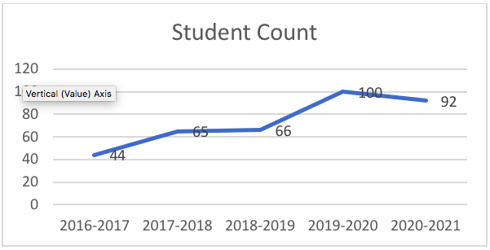

New Students vs. Withdrawals
In the 2018-2019, we experienced a large influx of new students. This is the year that Minera Panama, a large mining operation located approximately 2 hours further west of Five Stars Academy. Many families chose to set up their homes in the many beach communities near Five Stars Academy, specifically due to our school’s reputation.

In this current school year, we can see that the worldwide pandemic has made this the first year where we have experienced more withdrawals of students than registrations. See the next chart for additional information.

Note: We have had 6 students move out of the country or move to the city who have then specifically returned to our area because of the education they receive at Five Stars Academy. We have 2 more students in the same situation but unfortunately have not been able to return due to the pandemic.

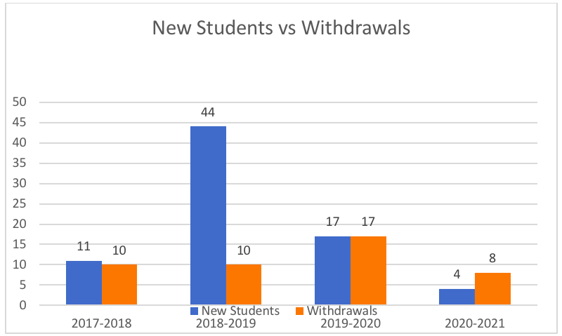

Reasons for Withdrawals
The #1 factor for student withdrawals is moving countries. We live in a transient community, where there is constant flow of new families and outgoing families.

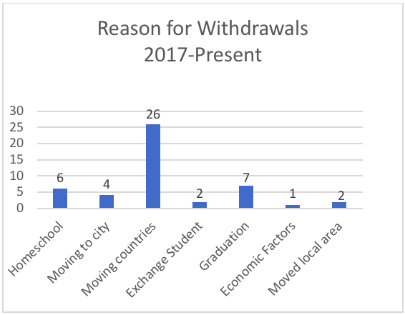

Student Population
Our largest numbers of kids are in the younger grades. We tend to see more withdrawals as kids get older and into higher levels as many families return to their home country or look for a larger school in an urban area. While we believe this trend will continue, we also see our area changing that allows more families with older children to stay, which includes the education we provide at Five Stars Academy.

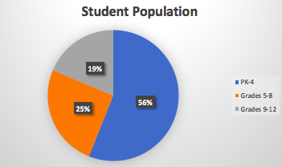
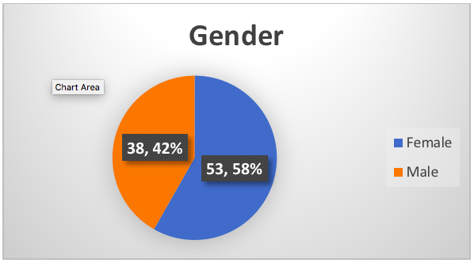
Regions
From the charts below, you can see 75% of our population is international, 25% from Panama, 15% from the U.S. We have students from 6 out of 7 continents.

Country information is a bit more difficult to categorize as many of our students carry 2 or more passports – depending on place of birth of parents, country of birth of students, and residency.

The charts below are further broken down by specific region. One of the most challenging issues we face is working towards closing the gap in education once we receive students from other countries or even from within Panama. We have found that the vast majority of students we receive are not at level in any of the subjects, but it is always especially difficult in Math and English. The new students who are above Kindergarten are often accustomed to different standards and different types of education.
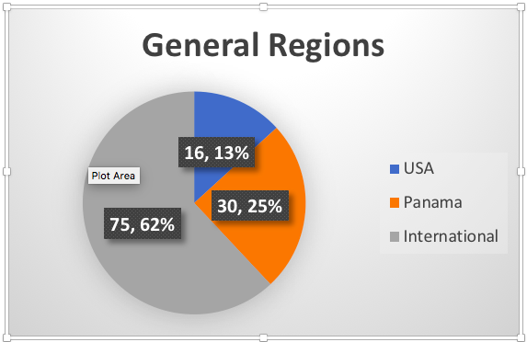
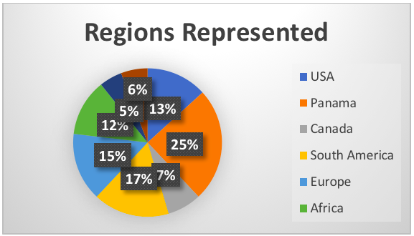
First Language
From the chart below, we have a majority of Spanish only speakers in the home. Many of our kids arrive having a basic understanding, or spoken in the home, of at least 2, and sometimes 3, languages. For the 2020-2021 school year, the languages spoken at home could be English, Spanish, French, Dutch, Afrikaans, Italian, Tagalog, Cantonese, Portugese, or Nyanja.

English: Beginning in the 2018-2019 school year, we instituted a requirement that all students in Grades 6 or above must have a working knowledge of English in order to be accepted. By Grade 8, students are studying Romeo and Juliet, which requires a higher understanding of English.

Spanish: We expect all students who stay with us through high school to graduate at a minimum, conversationally in Spanish. The challenge we have in teaching this subject is the levels of Spanish per grade vary greatly. In one grade, we can have a beginner Spanish speaker (learning colors, numbers, nouns) with a first language Spanish speaker. We continue to address these challenges through our Spanish program at school.

